Steps to deploy and run:   
1- build my custom jar :   
PS C:\Development\liferay-registration-service> ./gradlew clean build

Deprecated Gradle features were used in this build, making it incompatible with Gradle 8.0.

You can use '--warning-mode all' to show the individual deprecation warnings and determine if they come from your own scripts or plugins.

See https://docs.gradle.org/7.6.4/userguide/command_line_interface.html#sec:command_line_warnings

BUILD SUCCESSFUL in 3s

3 actionable tasks: 3 executed

PS C:\Development\liferay-registration-service>  
  
2- copy the jar file to C:\Development\liferay-portal\deploy  
  
3- on Liferay terminal you will see it is deployed correctly and start :   
  
2025-07-15 17:52:37.722 INFO [com.liferay.portal.kernel.deploy.auto.AutoDeployScanner][AutoDeployDir:212] Processing liferay-registration-service-1.0.0.jar

2025-07-15 17:52:47.187 INFO [fileinstall-directory-watcher][BundleStartStopLogger:71] STOPPED com.yourcompany.registration_1.0.0 [1395]

2025-07-15 17:52:47.523 INFO [Refresh Thread: Equinox Container: 69a0ed5c-b646-415d-901f-47d17a45e814][RegistrationObjectServiceWrapper:38] >>> Constructor hit for RegistrationObjectServiceWrapper

2025-07-15 17:52:47.524 INFO [Refresh Thread: Equinox Container: 69a0ed5c-b646-415d-901f-47d17a45e814][RegistrationObjectServiceWrapper:44] >>> ObjectEntryLocalService injected into RegistrationObjectServiceWrapper

2025-07-15 17:52:47.527 INFO [Refresh Thread: Equinox Container: 69a0ed5c-b646-415d-901f-47d17a45e814][BundleStartStopLogger:68] STARTED com.yourcompany.registration_1.0.0 [1395]  
  
so after that we go to Liferay portal   
  
from control panel object I add new custom object :   
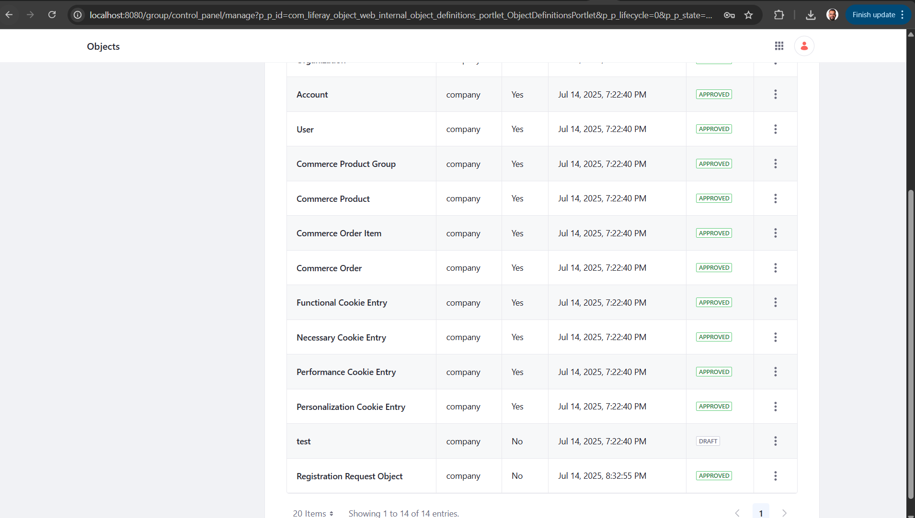  
  
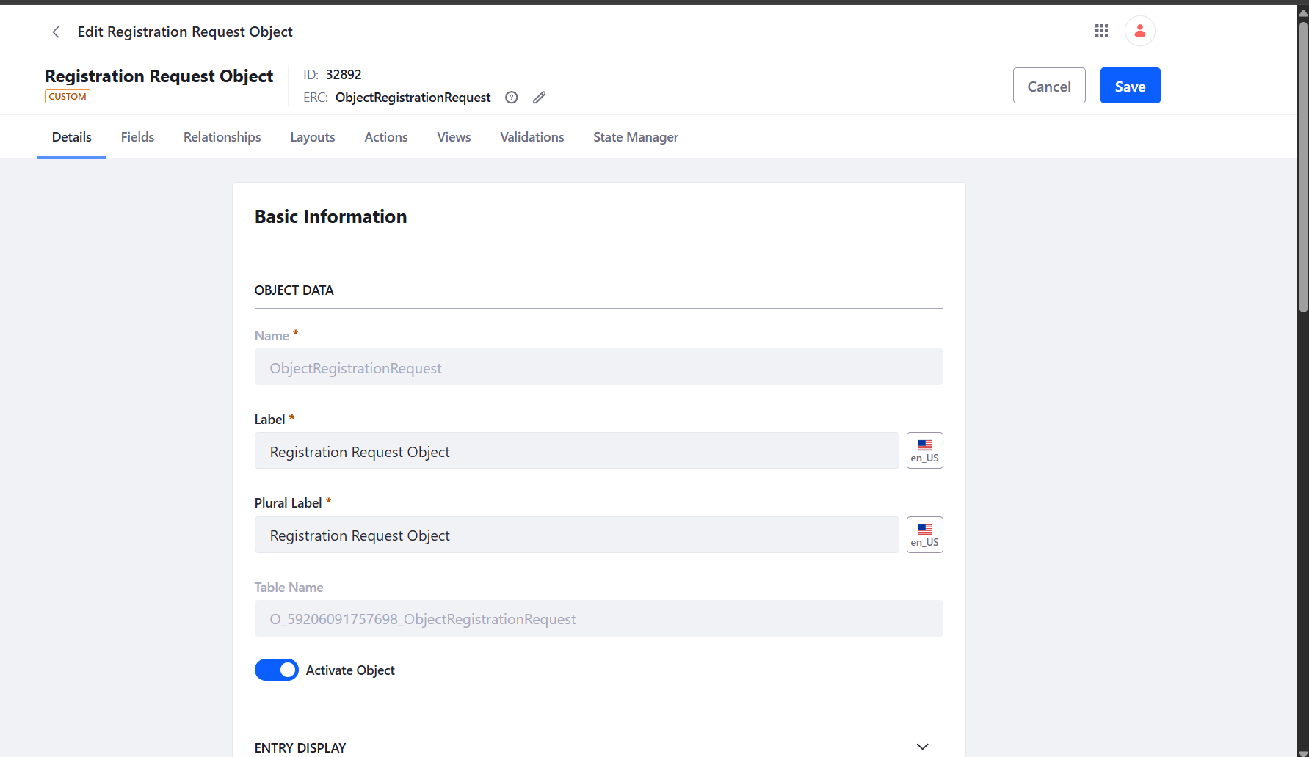  
  
With the fields that I want to show :   
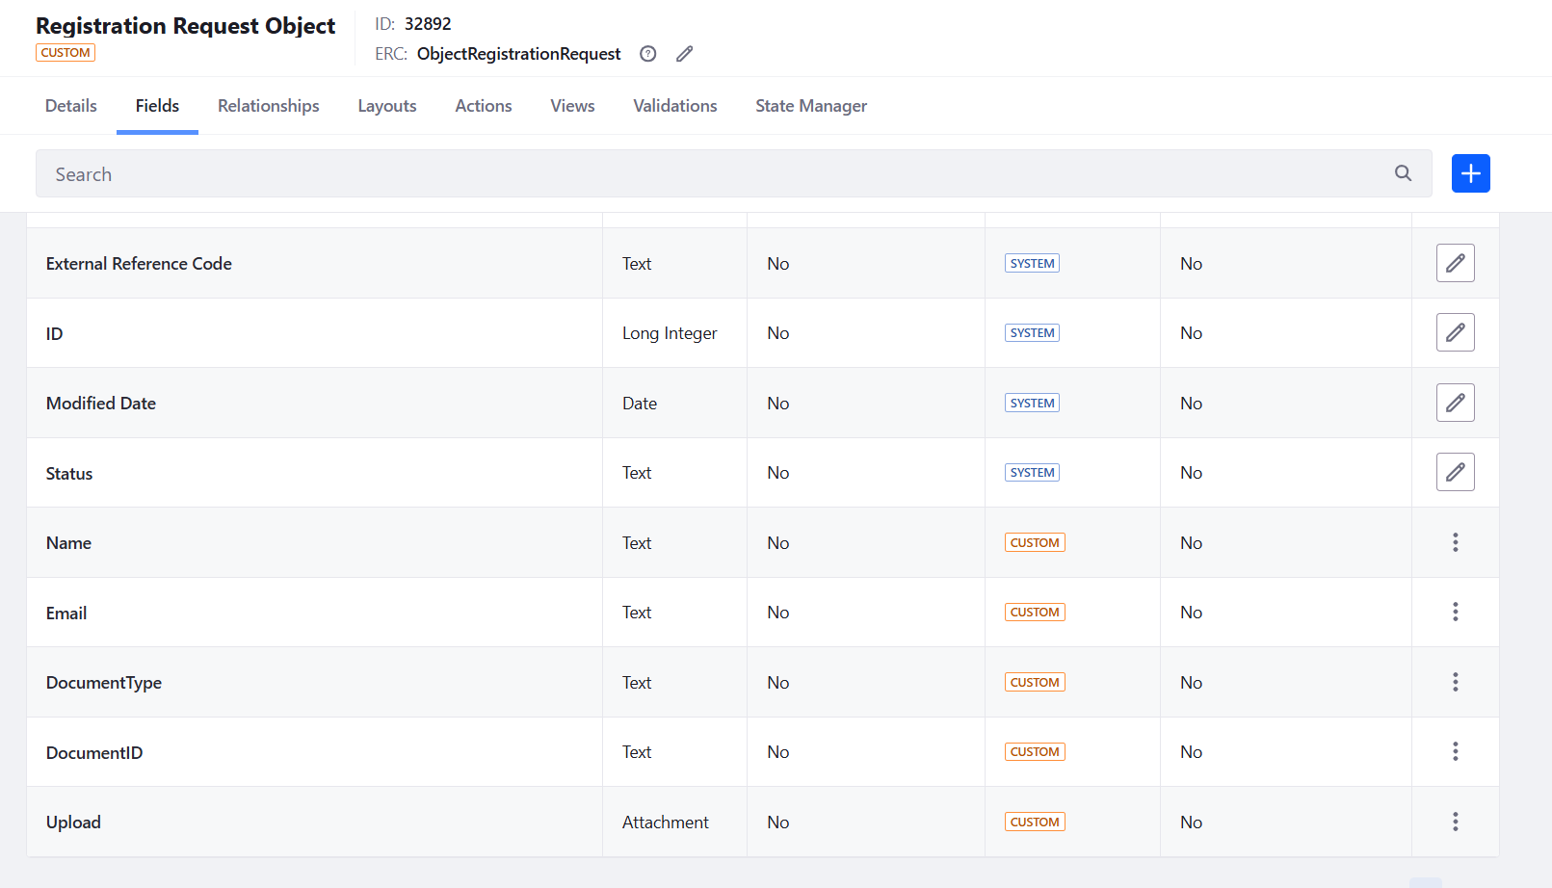  
  
then I go and create new page on page builder and add this object to it :   
  
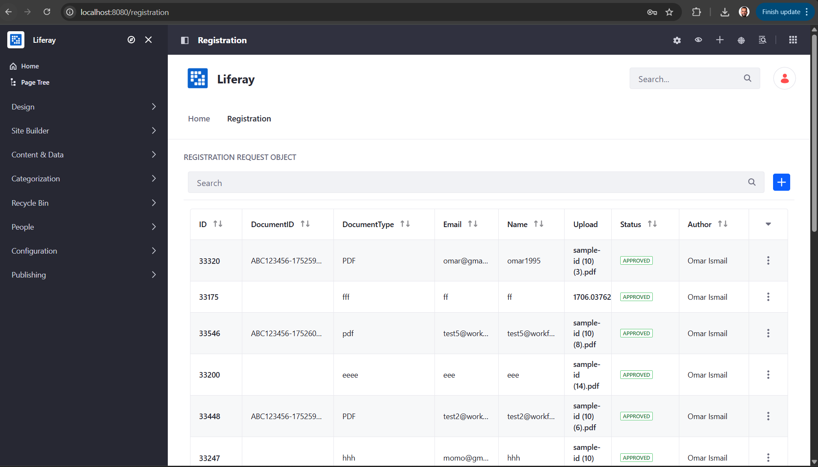  
  
so as you see I can add new entry from this :   
  
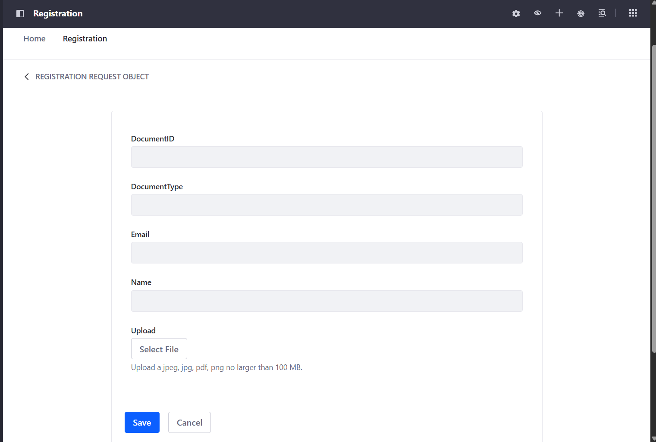

When click save my custom RegistrationObjectServiceWrapper will be triggered and extract the document ID from the PDF uploaded and save it to document id field inside the entry   
  
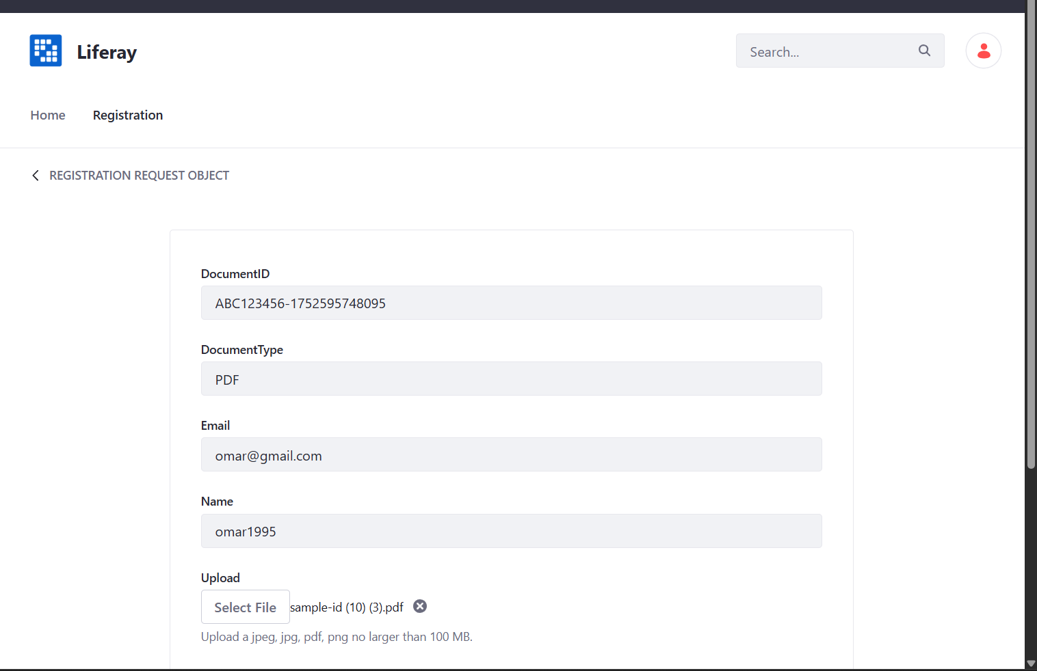

After add new entry as I link my custom object to workflow using Liferay workflow :   
  
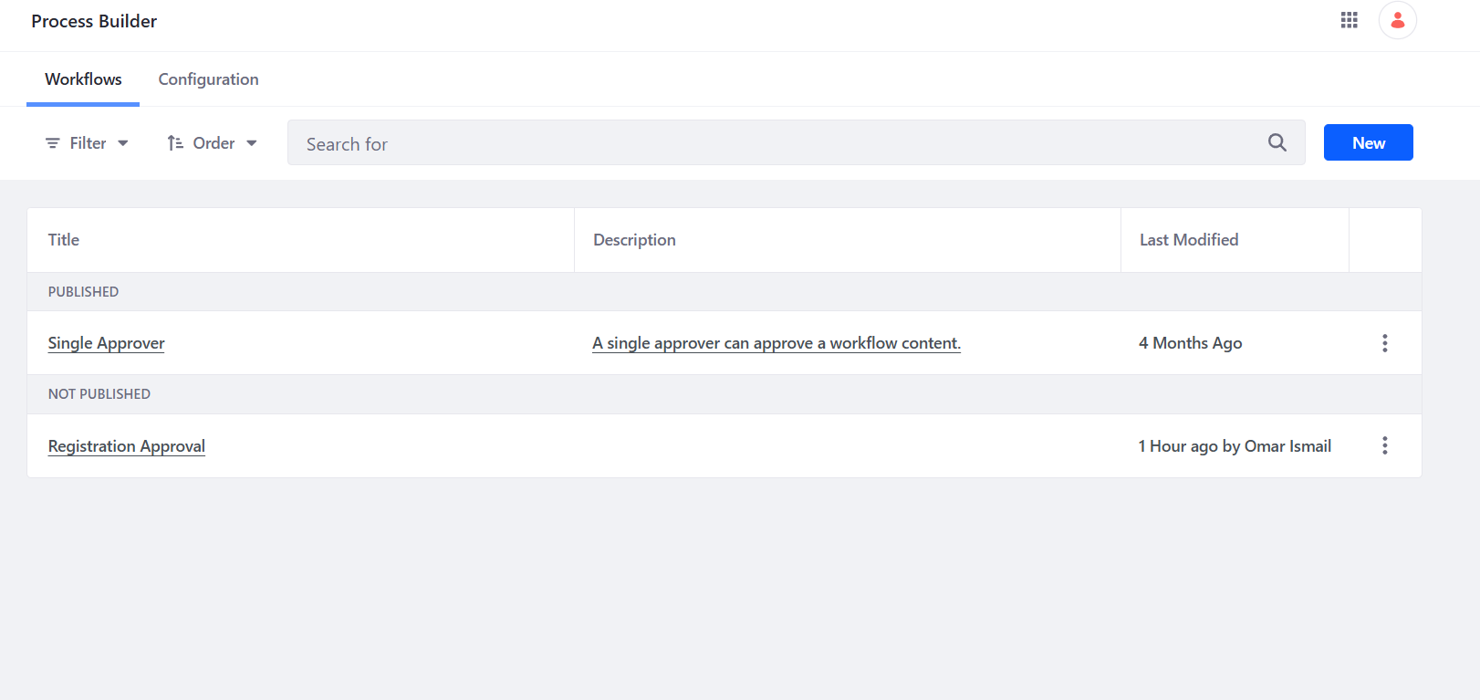

I assign single approver workflow to my custom object :   
  
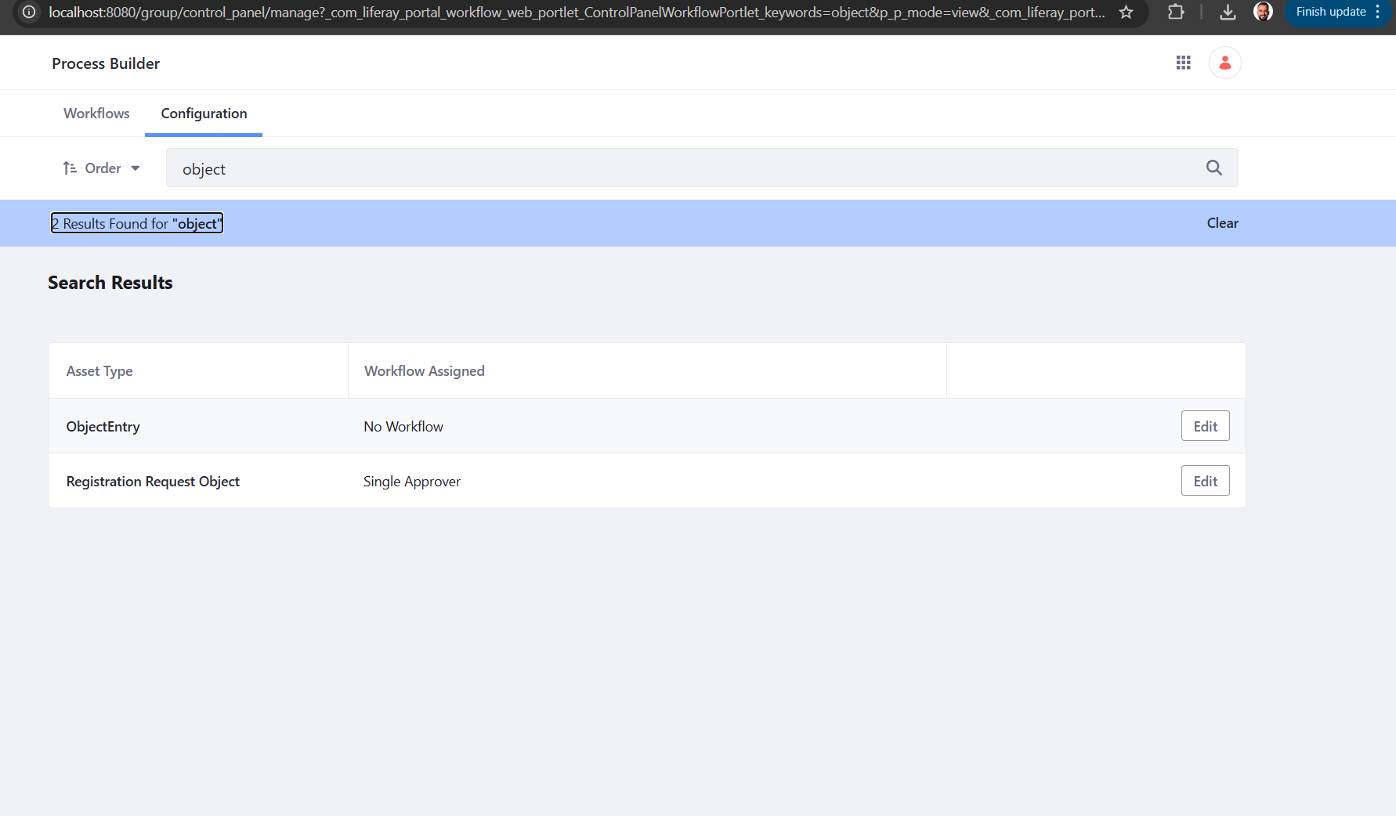  
  
so after save and add new entry for the first time the status is pending   
  
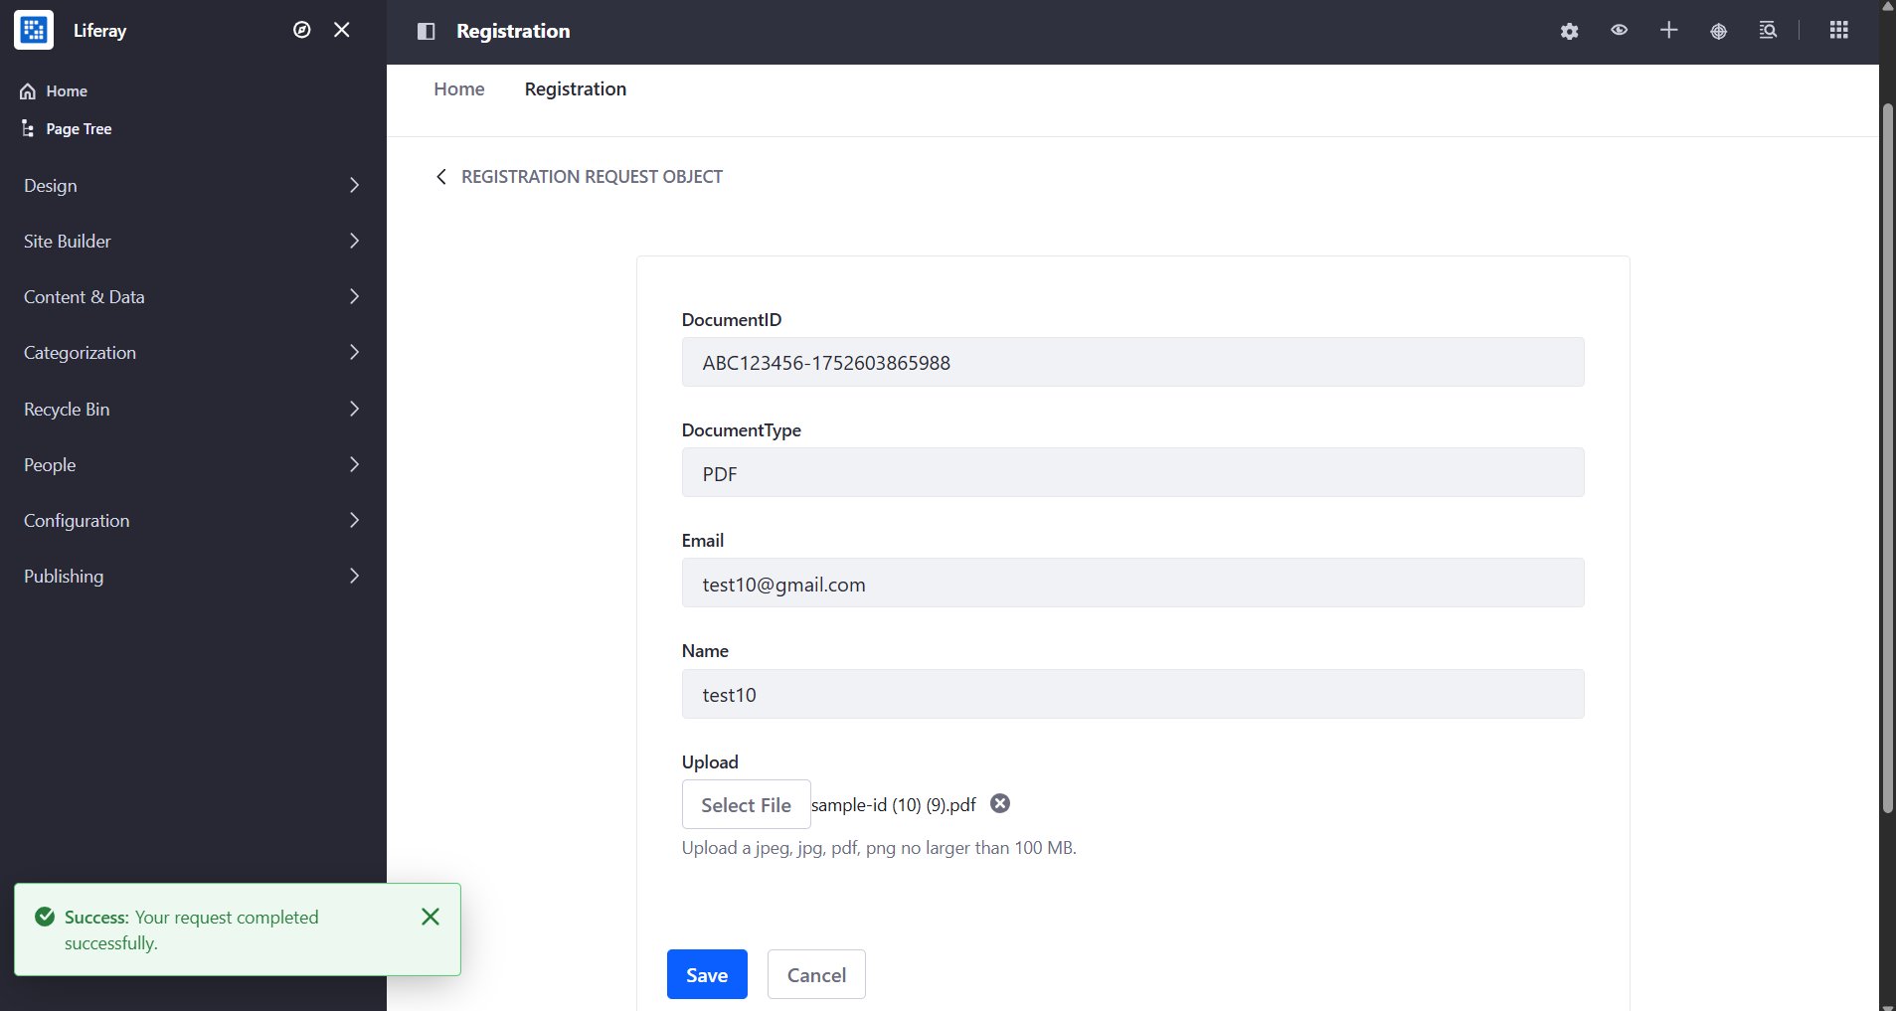



So now the admin will receive notification to review this task :   
  
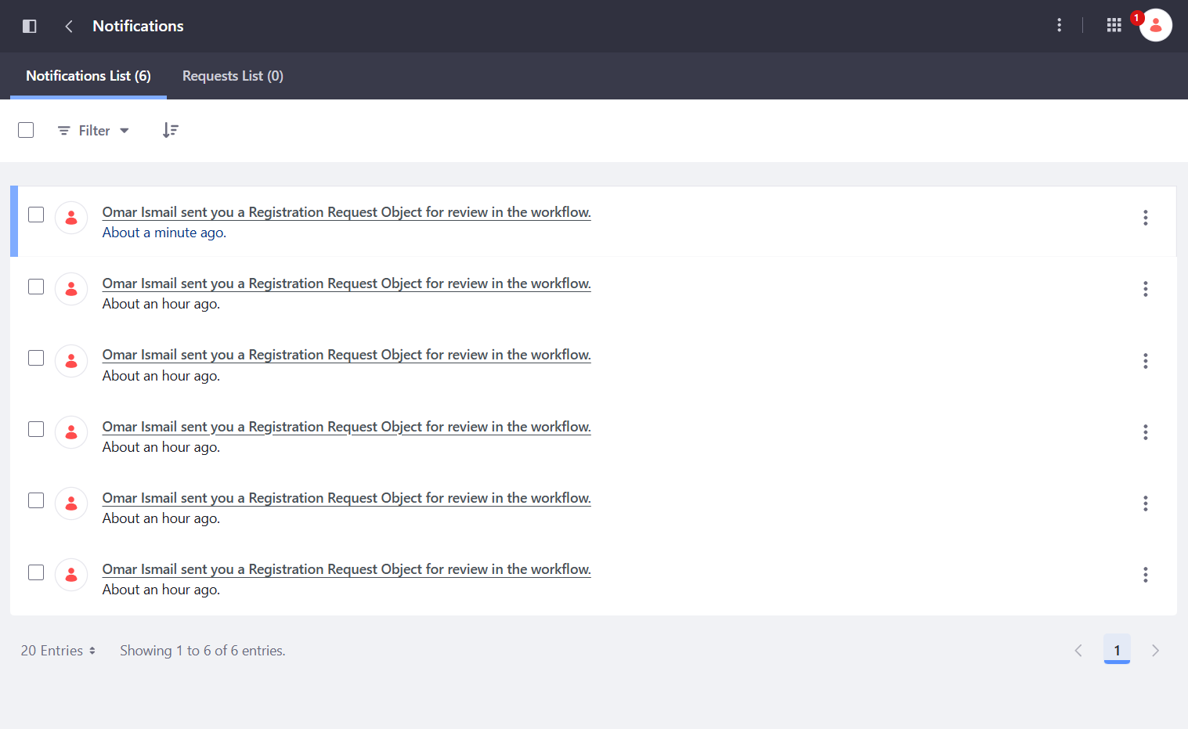

So, he can show all details and assign it to him and do the review:   
  
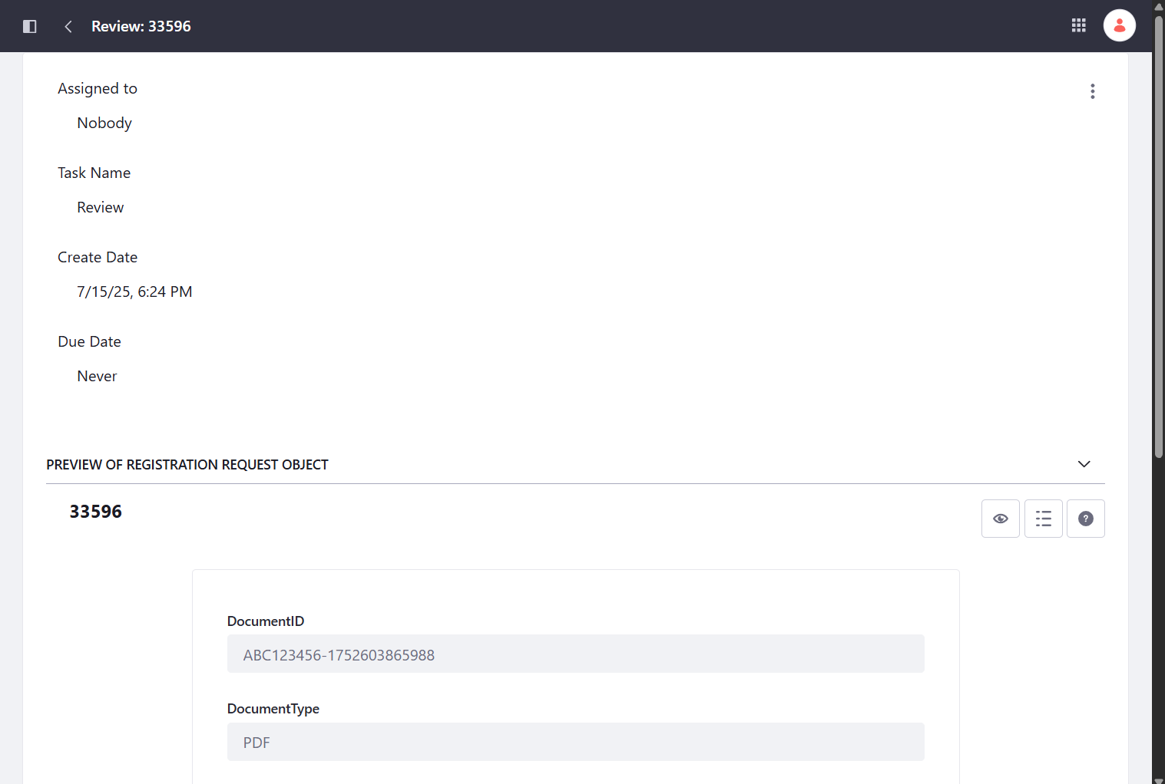  
  
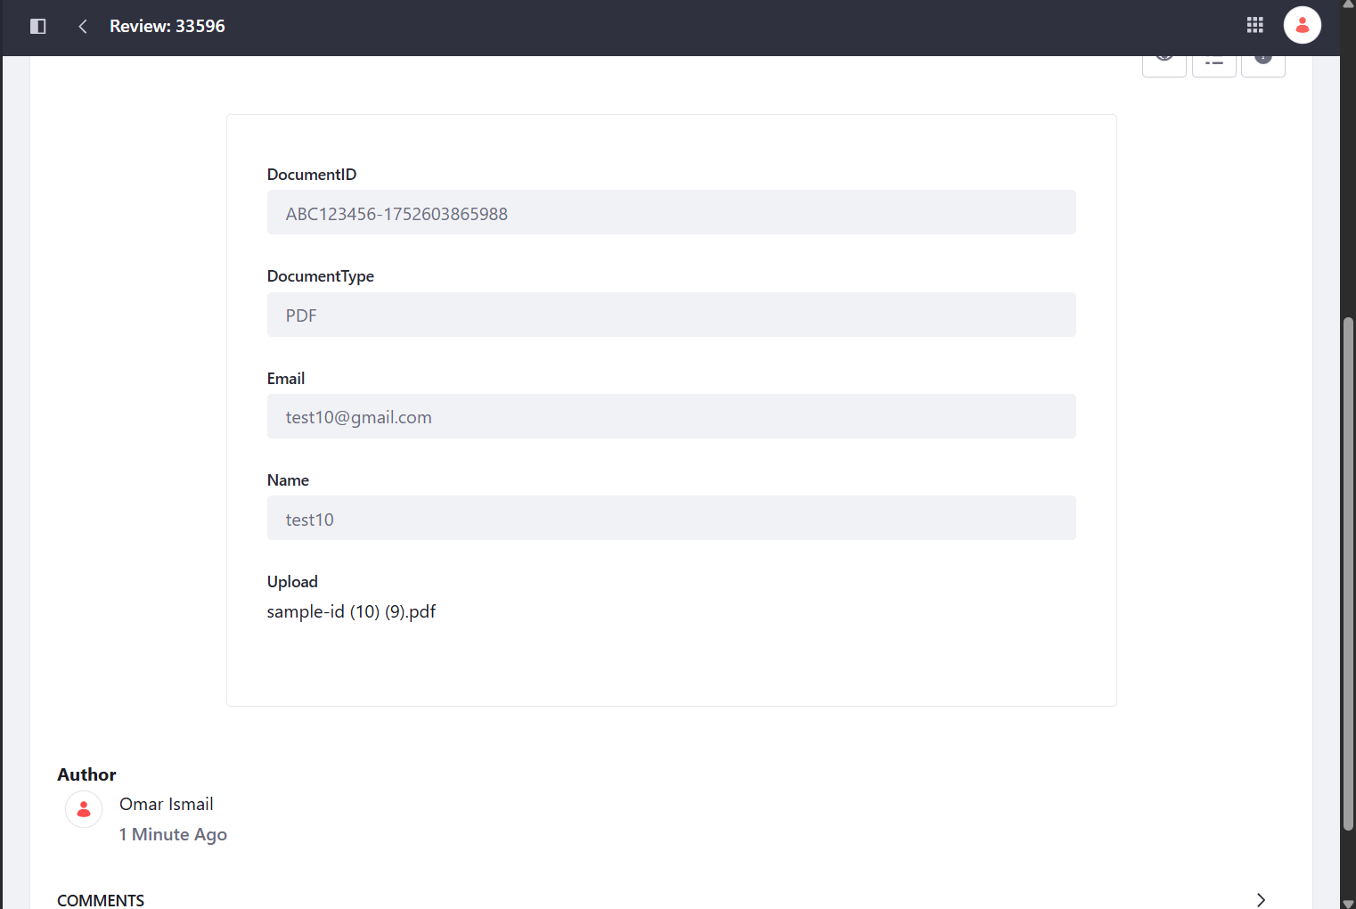

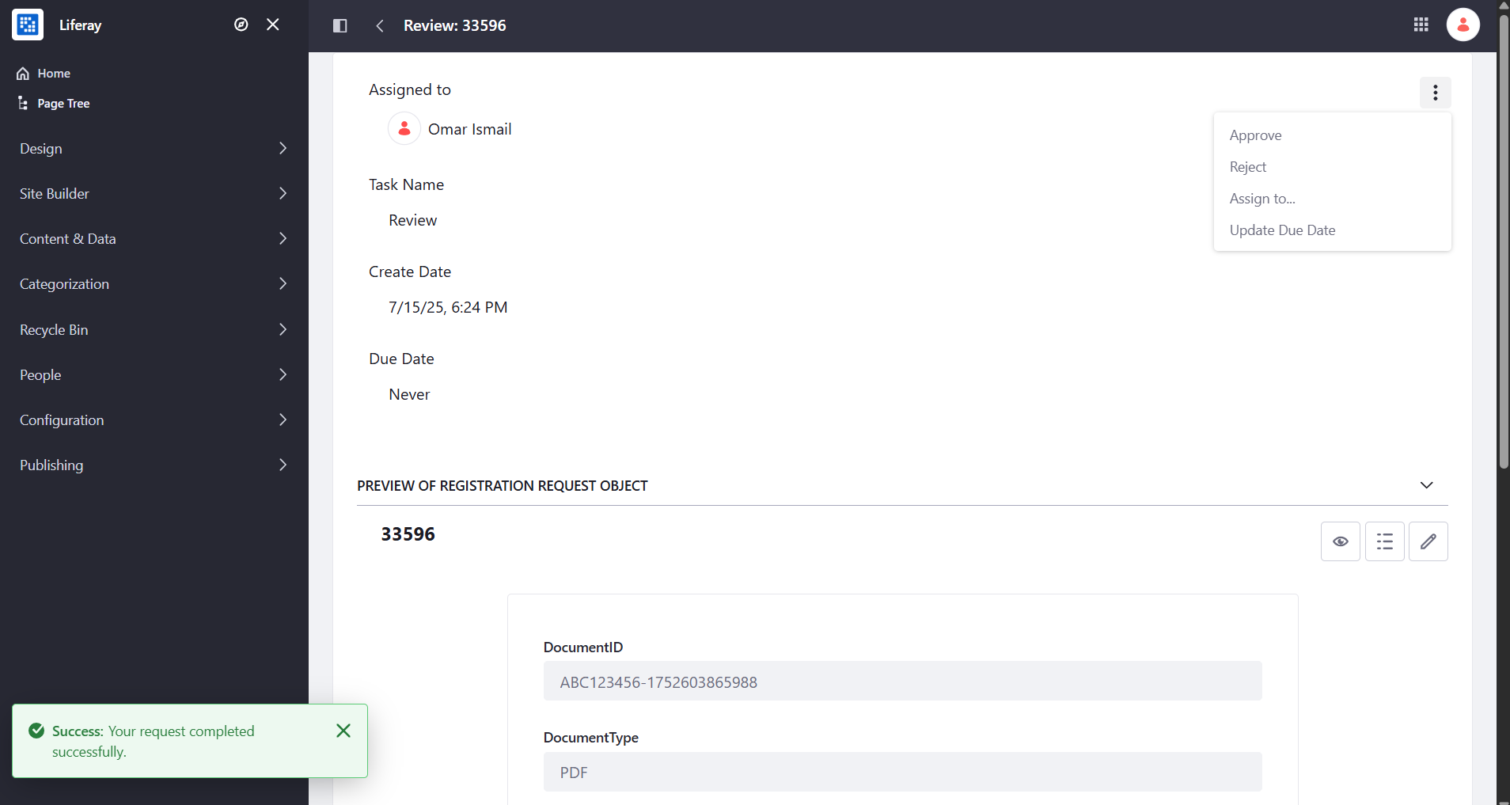

So after approve :   
  
  
the status changes to approved and at this step it should create new user using Liferay custom workflow handler but this step I did not know how to trigger it so this is the only miss item from my task ^_^